`



**Introduction to Tableau**

**Presenters:**

**Tanu Shukla &**

**Vineet Kumar**

**Tiwari**

**Presented to:**

**Deepanshu**

**Kumar**



**What is Tableau?**

Tableau is a software tool that turns complicated data into easy-to-

understand charts and graphs. Created in 2003, it makes data analysis

simple for everyone4just drag and drop, no coding needed.



**Why Tableau Matters**

**Make Better Decisions**

Turn confusing data into clear

pictures so you can decide

faster and smarter.

**Easy for Everyone**

Anyone can use Tableau to

explore data, from analysts to

managers4no coding

required.

**Get Real Results**

Help your business grow by

making decisions based on

data, not guesses.



**Tableau Core Components**

**Tableau Desktop**

Your personal tool to create charts,

dashboards, and data stories on

your computer.

**Tableau Server & Cloud**

Share your work securely with your

team online and manage everything

in one place.

**Tableau Public**

A free version where you can share

your work with everyone and see

what others have created.

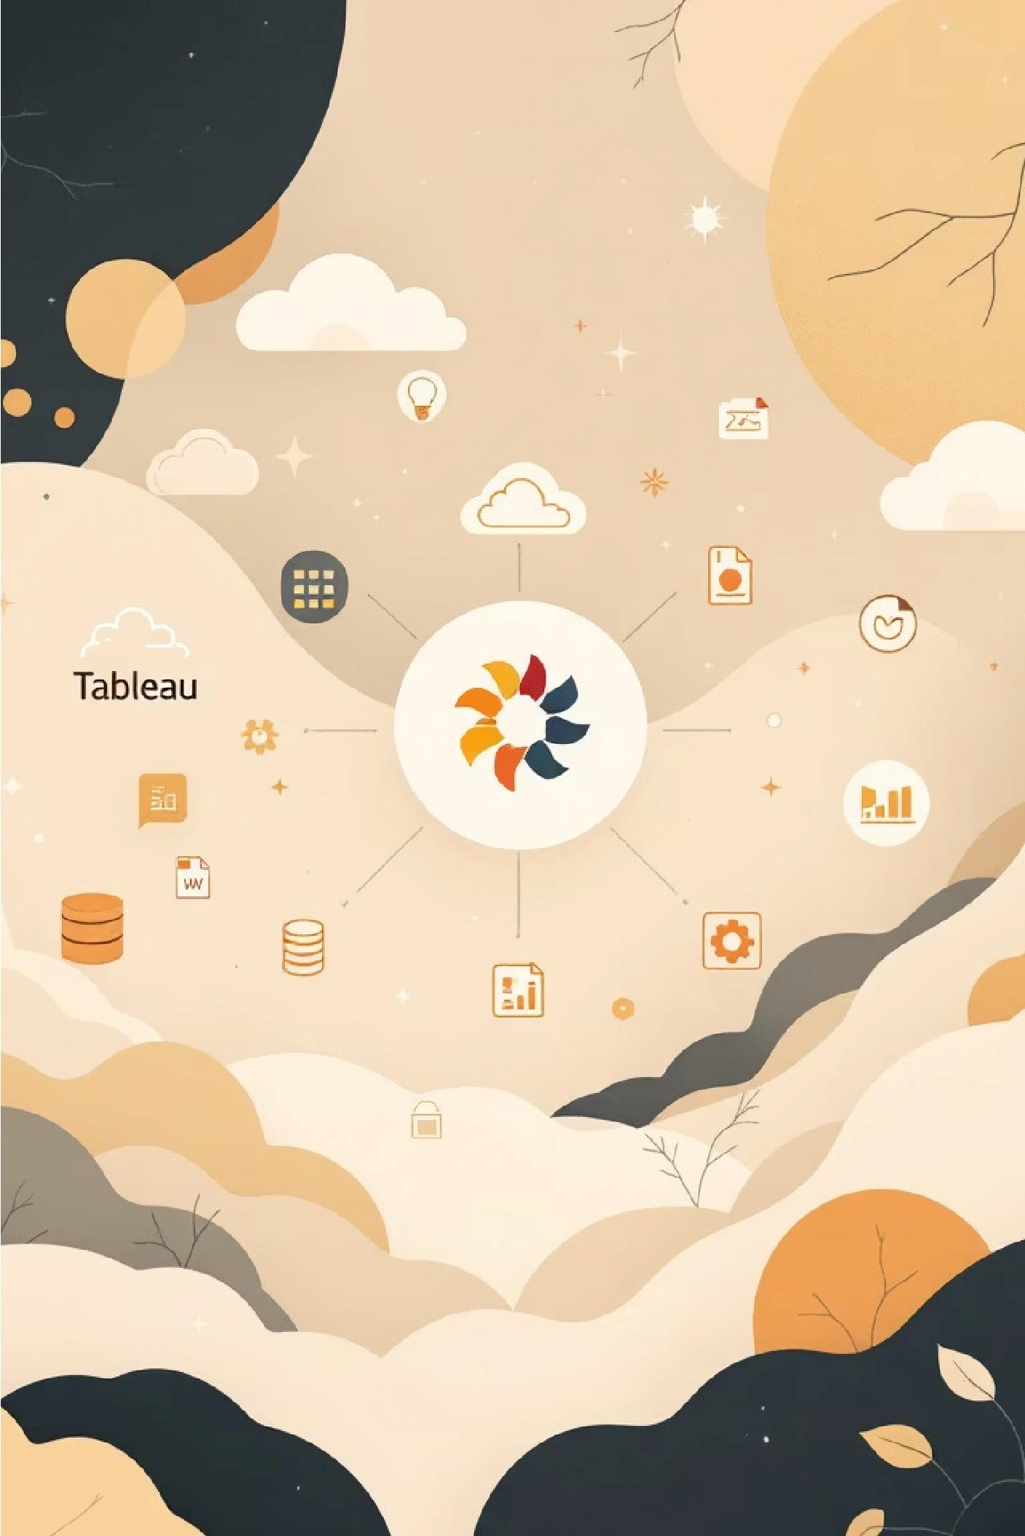

**Connecting to Your Data**

Tableau can connect to almost any place where you store data4Excel

files, databases, cloud storage, and more. It makes all your data easy to

access and use.

Connect live to see real-time updates, or save a copy of your data for

faster performance.

For example, you can analyze a store's sales data to see what's

selling well and what's making money.



**Building Visualizations: Drag, Drop, Discover**

A simple workspace where you organize your data by

dragging and dropping.

Make charts, maps, and tables just by dragging items

around4no coding needed.

Use filters and other tools to dig deeper and find what

matters in your data.



**Dashboards & Stories:**

**Present Your Insights**

Combine multiple charts and graphs into one dashboard to see all your

data in one place. Create stories that walk people through your findings

step by step.

For example, you can create a map showing sales in different areas to

quickly see which regions are doing well and which need improvement.



**Types of Visualizations in Tableau**

**Bar and Column Charts**

Compare different categories of data

easily. See how values stack up

against each other.

**Line Charts**

Track changes and trends over time.

Perfect for showing growth, decline,

or stability.

**Pie Charts & Treemaps**

Visualize parts of a whole.

Understand how each segment

contributes to the total.

**Maps**

Display data tied to locations. Great for geographic

analysis and regional insights.

**Scatter Plots**

Identify relationships and patterns between two different

measures to uncover correlations.



**Real-World Impact: Tableau in Action**

Big companies like Netflix and Amazon use Tableau to spot important trends and improve how they work. For example, stores

use it to understand their sales and make more money while keeping customers happy.

Over 1 million people use Tableau worldwide, creating a helpful community where users share ideas and support each other.

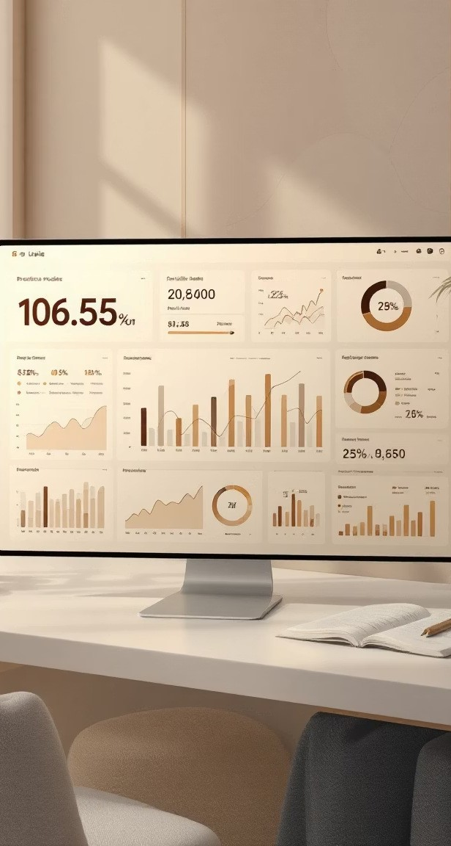

**What Makes Tableau**

**Powerful?**

Tableau helps you easily understand your data better. It gives you smart

tools to explore information, find key insights, and make sense of

complex numbers, moving beyond just simple reports.

**Advanced Analytics**

Use built-in tools to see

patterns, predict trends, and

forecast what's coming next

with your data.

**Custom Calculations**

Create your own formulas and

do math on your data to

uncover new insights and get

personalized analysis.

**Easy Data Blending**

Combine data from different places easily into one clear view, so you

can analyze everything together without a lot of hassle.



**THANK YOU**

**&**

**GOD BLESS YOU**